Third Culture Film Festival – And The Winners Are…
by Sam Bekemans - April 17, 2016
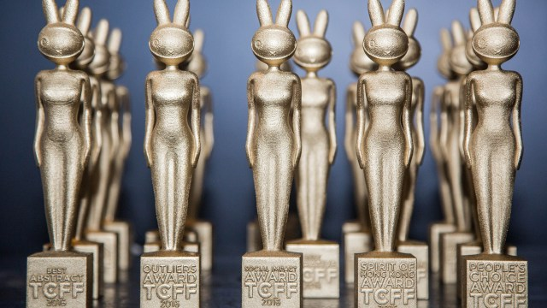
The Third Culture Film Festival Awards designed by Faiyaz Jafri – photo by Maximilian Lai
After a fantastic weekend, here are the winners of the Third Culture Film Festival 2016 Awards.

People’s Choice Award: Sick To My Bones – Nomattsland & Guy Davies
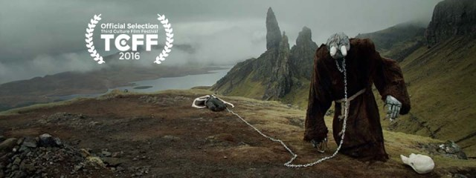

Outliers Award: People’s Choice Award: Sick To My Bones – Nomattsland & Guy Davies

Spirit of Hong Kong: Doggy Love
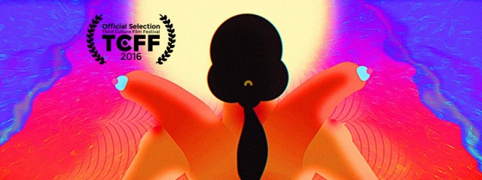

Best Abstract: All Rot – Max Hattler
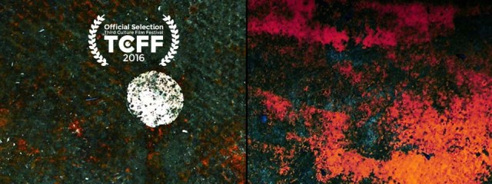

Best Experimental: Doctor Pafke – Kris Verdonck
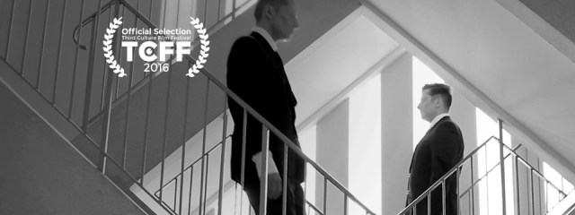

Best Animation: Doggy Love – Wong Ping

Best Narrative: An Angry Man – Jannik Dahl Pedersen

Best Actor: AJ Buckley in “Microwave” – Neil Champagne

Best Actress: María Hervás in “If They Had Eyes” – Carlos Polo Menárguez
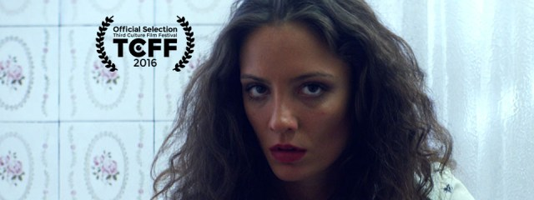

Best Director: The Chicken – Una Gunjak
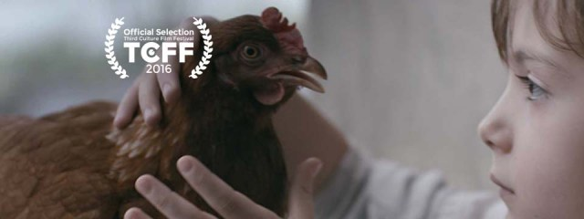

Best Animated Character: The Horse Raised By Spheres – David O’Reilly
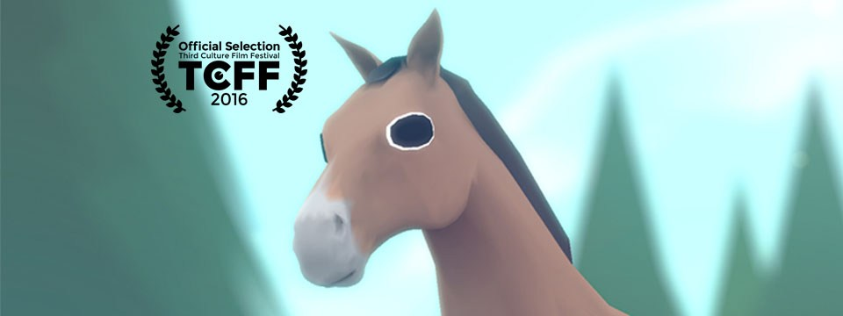

Best Production Design: The Fisherman – Alejandro Suarez
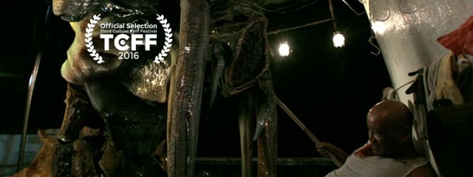

Best Music: And We’ll Eat Flowers – Loïc Paillard
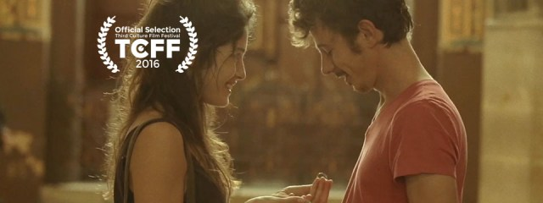

Best Costume Design: Extreme Pinocchio – Pascal Chind

Best Action Sequence: Mediation – Francisco Lorite
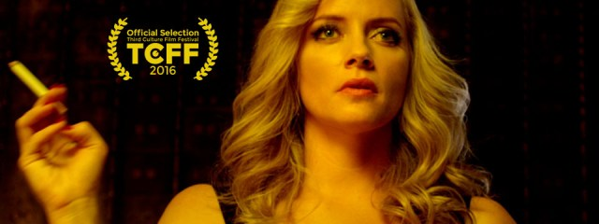

Best Director of Photography: And We’ll Eat Flowers – Loïc Paillard

Best Editor: The Chicken – Una Gunjak

Best Sound Design: In A Forest – Fons Schiedon
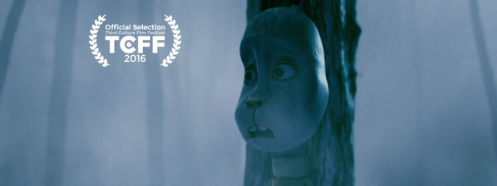

Social Impact Award: Back Hometown – Li Bin

Oram-Jafri Award: The Wolf – Nadan Pines
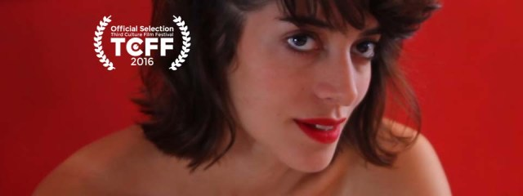

Third Culture Film Festival 2016 – The Judges, The Nominations, The Prize!
The Judges:
Selected from a variety of cultural backgrounds, the judges are also from a variety of artistic backgrounds. TCFF intended to have a diverse matter of opinion so that all genres and styles of films had an equal chance of gaining deserved recognition by winning one of the 20 TCFF prizes at this year’s TCFF Awards.
So let us meet the judges!

MIKE LEEDER
Based out of Hong Kong since 1990, Leeder has worked both in front and behind the camera as an occasional actor, Casting Director, Fixer and Producer for such projects as Jet Li’s Fearless, Jackie Chan’s Rush Hour 3 & Kung Fu Yoga, The Raid 2, Tracer/Truy Sat, Keanau Reeves Man of Tai Chi, RZA’s Man with the Iron Fists 1 & 2, One Million Klicks, Jean-Claude Van Damme’s Pound of Flesh, Helios, Rise of the Legend, Goldstone, and Ultimate Justice. He is currently in pre-production on a number of Film & TV projects with various partners including 108 Media. He is and always shall be a Gwailo.

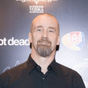SEAN TIERNEY
Sean Tierney is a recovering academic and freelance film critic. His Youtube channel, The SIlver Spleen, focuses on Chinese-language film reviews and related topics like location visits and his own experiences in local film.

TAVIA JIANG
Tavia Jiang grew up in a family surrounded by the world of arts. Her grandfather was a famous calligrapher, her father dedicated a life-long career to the film business, and her mother won awards for her work as a Chinese Opera singer. Tavia has always had an affinity and an enthusiasm for art in all its forms, including painting, photography, sculpture, performance art and cinema. Tavia is currently working at Above Second, a HK gallery which has been busy curating for exhibitions with various local and international artists. She believes that talented emerging artists should be given more of a platform to showcase their works.

YAZ PLEITGEN
Yaz Pleitgen is a truly international and ‘made in Hong Kong’ writer, producer, and director. She has worked on multiple award-winning commercials, campaigns, films, branded content, and television programmes. Also, as a Chindian female filmmaker, she balances out the specific ratio of gender and race representation on the panel.

EMILIE GUILLOT
Emilie is a local French celebrity in Hong Kong. She is a resident since 2002. She has dedicated herself to the artistic community, and founded HK Theatre Association in 2007. Emilie is an actress, a drama coach, a director, and producer of a large number of live performances. In 2015, she has directed her first feature film (L’arrivée d’un Typhon), an independent film shot and set in Hong Kong. Not only did Emilie star in this film, she is also the writer and producer.

ADAM TAM
Adam Tam started as a lighting designer and finally made his way as a well-known director of cinematographer, Given his growing reputation, he was invited to participate some of the best film makers in the world. In addition, Adam is also one of the high-definition (HD) technology pioneers in Hong Kong. With the expertise in advertising production and strong sense of market trend, Adam set up his own advertising company specializes in above-the-line marketing productions. He was elected as the Vice-President of the Hong Kong Society of Cinematographers (HKSC) since 1995, and then assigned to Board of Director’s Council Vice Chairman of Hong Kong Film Awards. Having a vision to spread the spirit of movie industry, Adam is currently teaching in Film Professional Training Programmed aiming to nurture a new breed of blood for the future of Hong Kong movie industry.

The Nomination Process:
Want to know how the films were selected? Here it goes:
Step 1: OFFICIAL SELECTION: The Curator, and co-founder, Faiyaz Jafri, selected 70 films from over 1800 films submissions over the course of 9 months from 2015-2016.
Step 2: A short list of the films were made and these films were nominated to win awards in 20 different categories. Winners from 18 categories will be decided by our panel of judges.
Step 3: The judges were given the official nominations and will decide between them on which they think should win. The awards will be announced on Sunday, 9pm @ the TCFF Awards Ceremony @ Loft22, California Tower. Everyone is invited!
But wait! There are 2 more awards?!

The Oram-Jafri Award
Named after the founders of the festival. The founders wish to reserve the right to honour a film that they think deserves outstanding recognition.

The Audience Award
This is where you come in!
The audience, you, are allowed to vote for your favorite film to win an award! One person, one vote! Every person that has a ticket to one of the 6 Official Screening Blocks (2 each evening of the festival), will be able to fill in a ballot and vote for their favorite film of that block. The film with the most votes out of all the blocks wins! The LKF Group will present the award to the winner at the awards ceremony.

The Prize!
The founders were very keen to use the festival as a platform to give recognition to independent artists. In this spirit of this, each year’s awards trophy will be designed by a Hong Kong artist and 3D Printed!
As this is a very special year as the festival’s inaugural year, the team wished to give this honour to its curator and co-founder, Faiyaz Jafri.

CHECK OUT THE NEXT EXCITING FILM IN THE TRILOGY, “MAY YOU NEVER DIE”. YOU CAN ADD SUPPORT TO DRIVE ITS SUCCESS BY CLICKING ON THE LINKS BELOW
www.mayyouneverdie.com

https://www.indiegogo.com/projects/may-you-never-die-a-short-film--2#/

